Samuel Ilyayev
CS 230 Module 1
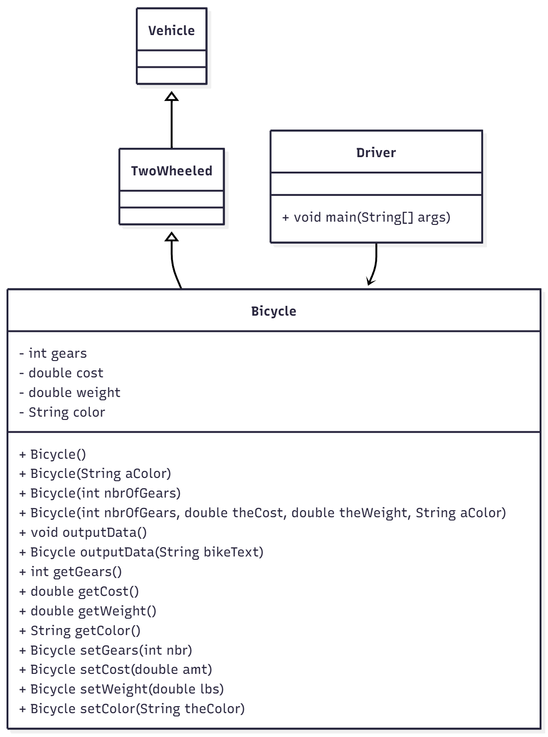
Above is the UML class diagram that shows relationships as well as the structure of the Java code consisting of classes like Vehicle, TwoWheeled, Bicycle, and Driver.

At the highest level of hierarchy, we have the Vehicle class, which is the base class that captures the most general idea of a vehicle. This is followed by the TwoWheeled class, which is a subclass of Vehicle representing a subclass of vehicles that are Two-Wheeled. This is in turn followed by the Bicycle class, which is a subclass of TwoWheeled representing a subclass of Two-Wheeled vehicles that capture more specific details of a bicycle, including the number of gears, price, weight, and color. This is followed by the Driver class

This code exemplifies the application of the following object-oriented programming (OOP) concepts:

Inheritance:
Bicycle inherits from TwoWheeled, which in turn inherits from Vehicle. This shows the "IS-A" relationship, a bicycle is a two-wheeled vehicle.

Encapsulation:
The Bicycle class uses private instance variables (gears, cost, weight, and color) with public getter and setter methods, protecting internal data from direct access while allowing controlled modification.

Polymorphism:
The Bicycle class includes overloaded constructors and methods such as outputData() and outputData(String), showing compile-time polymorphism.

Abstraction:
The hierarchy abstracts general concepts into higher-level classes (Vehicle, TwoWheeled) and implements detailed behavior only in the subclass (Bicycle).

Method Chaining:
Setter methods in Bicycle return the current object (this), enabling chained calls like
myBike.setColor("Blue").setGears(21).setCost(350.00);
This provides a more fluent and readable interface.

Together, these principles demonstrate a clear, modular, and extensible design that supports code reuse and maintainability.

